
Create a lakehouse
DP-600 Lab 01


Waleed Butt

Contents
Introduction 2
Create a workspace 2
Create a lakehouse 3
Upload a File 4
Load file data into a table 5
Use SQL to query data. 6
Visualize query 7
Wrap up 9

Create MS Fabric Lakehouse

Introduction
Large-scale data analytics solutions have traditionally been built around a data warehouse, where data is stored in relational tables and queried using SQL. With the growth of “big data” along with availability of low-cost storage and cloud compute technologies has led alternative approach to analytical data the data lake. Data lake stores data as files without imposing any fixed schema for storage. Data engineers, scientist , analyst seek to benefit from both warehouse and data lake approach by combining them into a data lakehouse. In data lakehouse, data is stored in files with a relational schema applied as metadata layer so they can be queried using traditional SQL semantics.
In this project we will see how to make a lakehouse and use a metastore for relational objects.

Create a workspace
- Sign into fabric
- In the menu bar on the left select workspace or click on the button with “+ workspace” and create a workspace with name of your choosing. For example, sales_data_workspace
- Once the workspace is create it will like this
Figure 1 Empty workspace
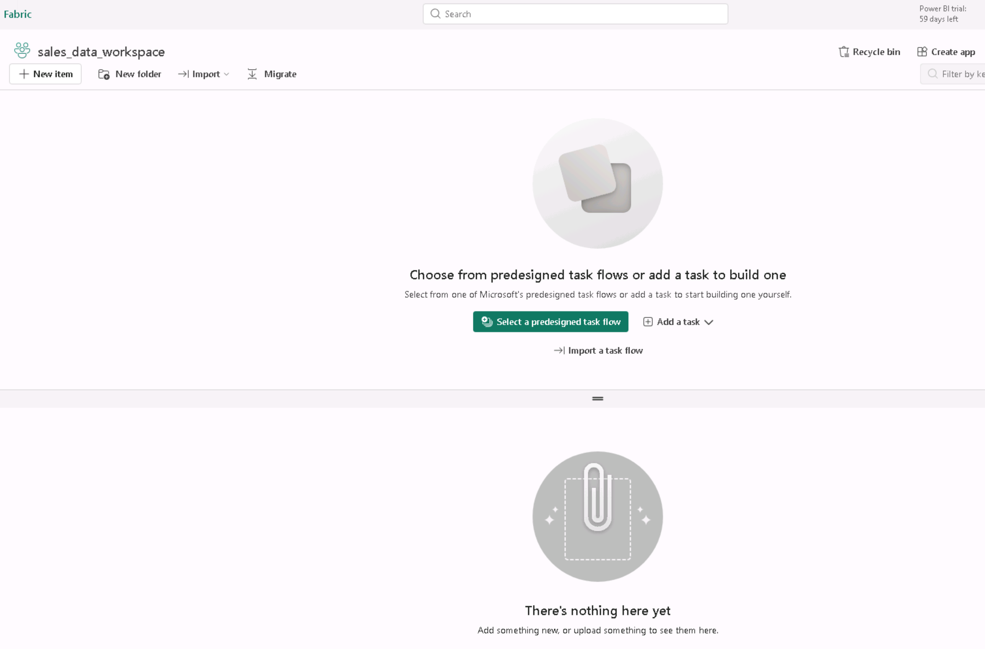

Create a lakehouse
- In your empty workspace on the left top there is button for “+ New item”, click on it.
- A window slide out, on it choose lakehouse
- A popup will ask you give a name to your lakehouse, name of your choosing. For example, sales_data_lakehouse. Make sure the location sections below the name shows your workspace.
- A lakehouse will open with explorer pane on the left side wit the name of your lakehouse and two major sub folders, Tables and Files.
Figure 2 Empty Lakehouse
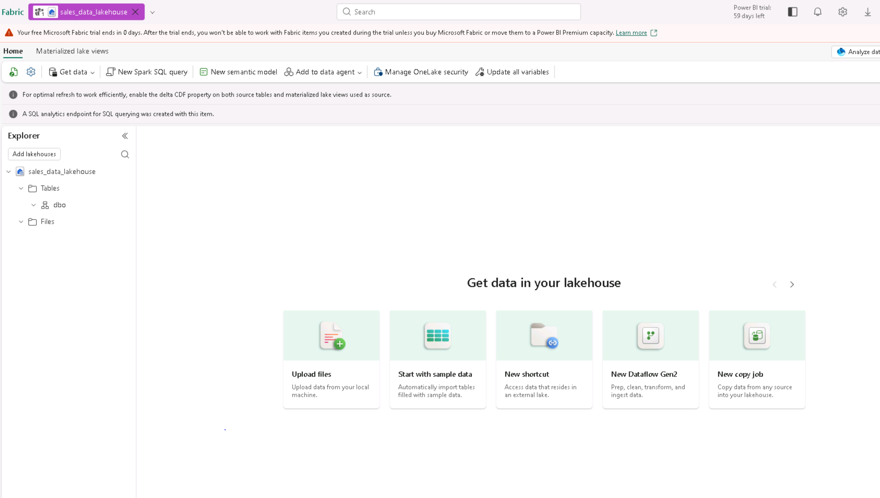

Upload a File
One thing about lakehouse is it can store unstructured or semi-structured data and the semi-structured data can then be converted to structured data like relational table. Here we are going to add a csv and the make into relation table
- Goto https://raw.githubusercontent.com/MicrosoftLearning/dp-data/main/sales.csv and save it on computer as sales.csv
- On the explorer pane on the left mouse over Files folder and click “…” ellipsis, a context menu will popup, click on new folder and make a folder with the name sales.
- In the … menu for the new sales folder, select Upload and Upload files, and then upload the sales.csv file.
- On the sales folder click on ellipsis “…” and click refresh and then click on sales folder and you will see sales.csv on the right side of the explorer pane

Figure 3 sales.csv file inside sales folder in the Files folder
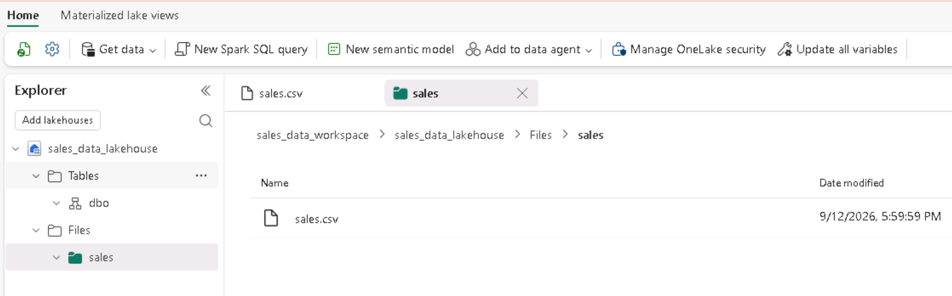

Load file data into a table
Lakehouse gives you the ability to take the .csv file you uploaded and turn into a delta table (Relational table) where you can use SQL to analyze the data.
- In the explorer pane select Files folder and it will show the sales.csv file on the right side.
- Select the menu icon “…” the 3 ellipsis on the right side of the filename sales.csv
- In the load to table menu option click on new table. Make sure the use first row as header is checked.
- Wait till its done then on explorer pane on the “…” for Tables folder click refresh
- You will see a new table in dbo>sales. This the relational table created in lakehouse.

Figure 4 Relational table created from sales.csv
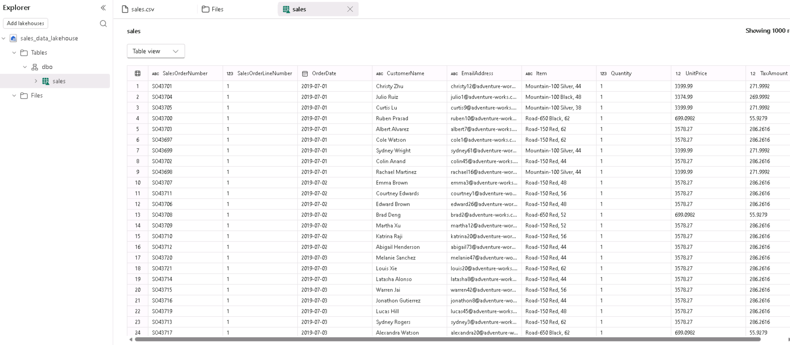

Use SQL to query data.
Now we have a table we can use sql to query data
- On the top right inside the Analyze data with drop down option click on SQL Analytics Endpoint
Figure 5 Analyze data with options
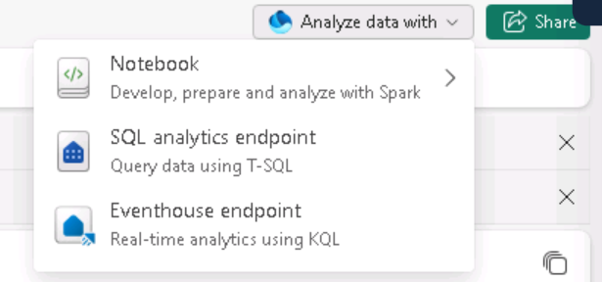
- Use the New SQL query button to open a new query editor, and enter the SQL query shown in the image below and press RUN
Figure 6 SQL query run results
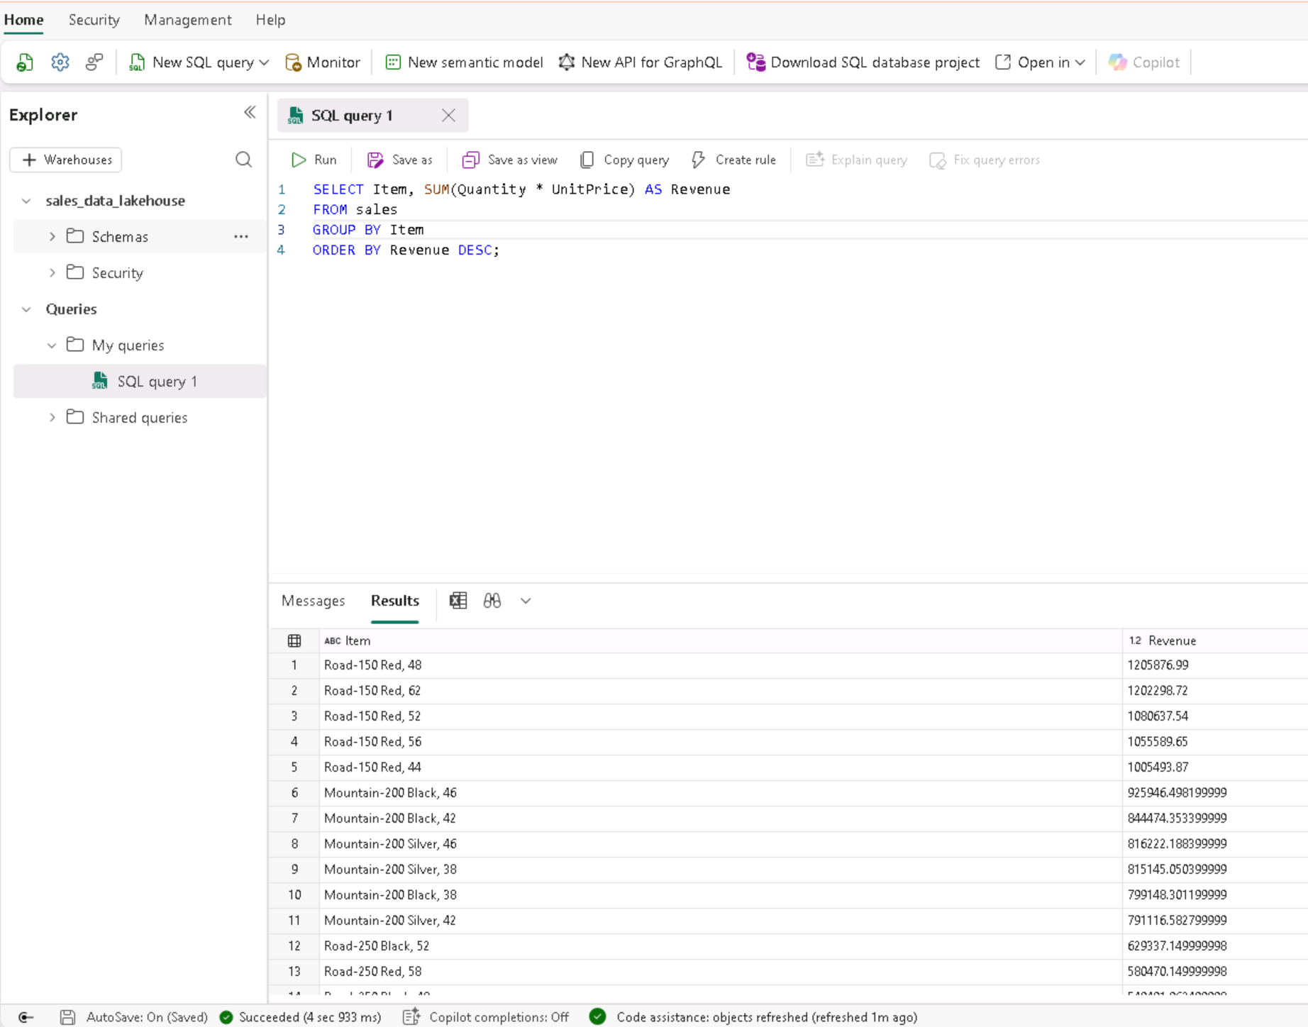

Visualize query
Lakehouse gives you the ability to use power query to visualize the data.
- On the toolbar, expand the New SQL query option and select New visual query.
- Drag the table from the explorer pane on the left in lakehouse>Schemas>dbo>Tables>sales onto the right side. It will look something like below
Figure 7 Using visualize query
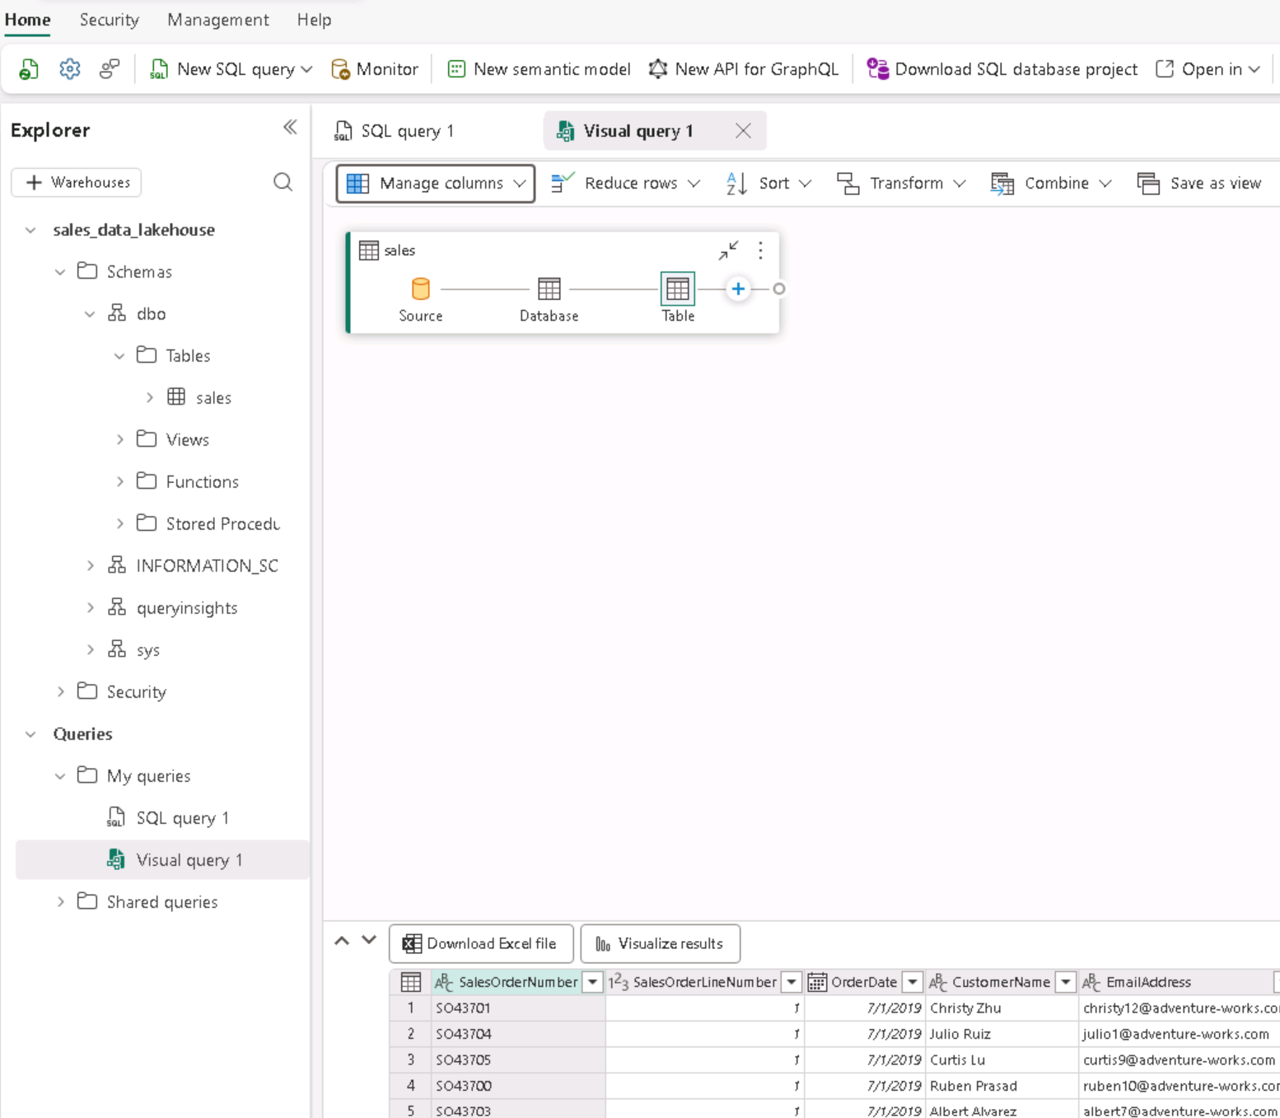
- Select manage columns from the Manage Columns drop down menu and choose SalesOrderNumber and SalesOrderLineNumber
- In the Transform menu, select Group by. Then group the data by using the following Basic settings and then select OK:
- Group by: SalesOrderNumber
- New column name: LineItems
- Operation: Count distinct values
- Column: SalesOrderLineNumber
- The result will look like this
Figure 8 Result of using power query to transform data
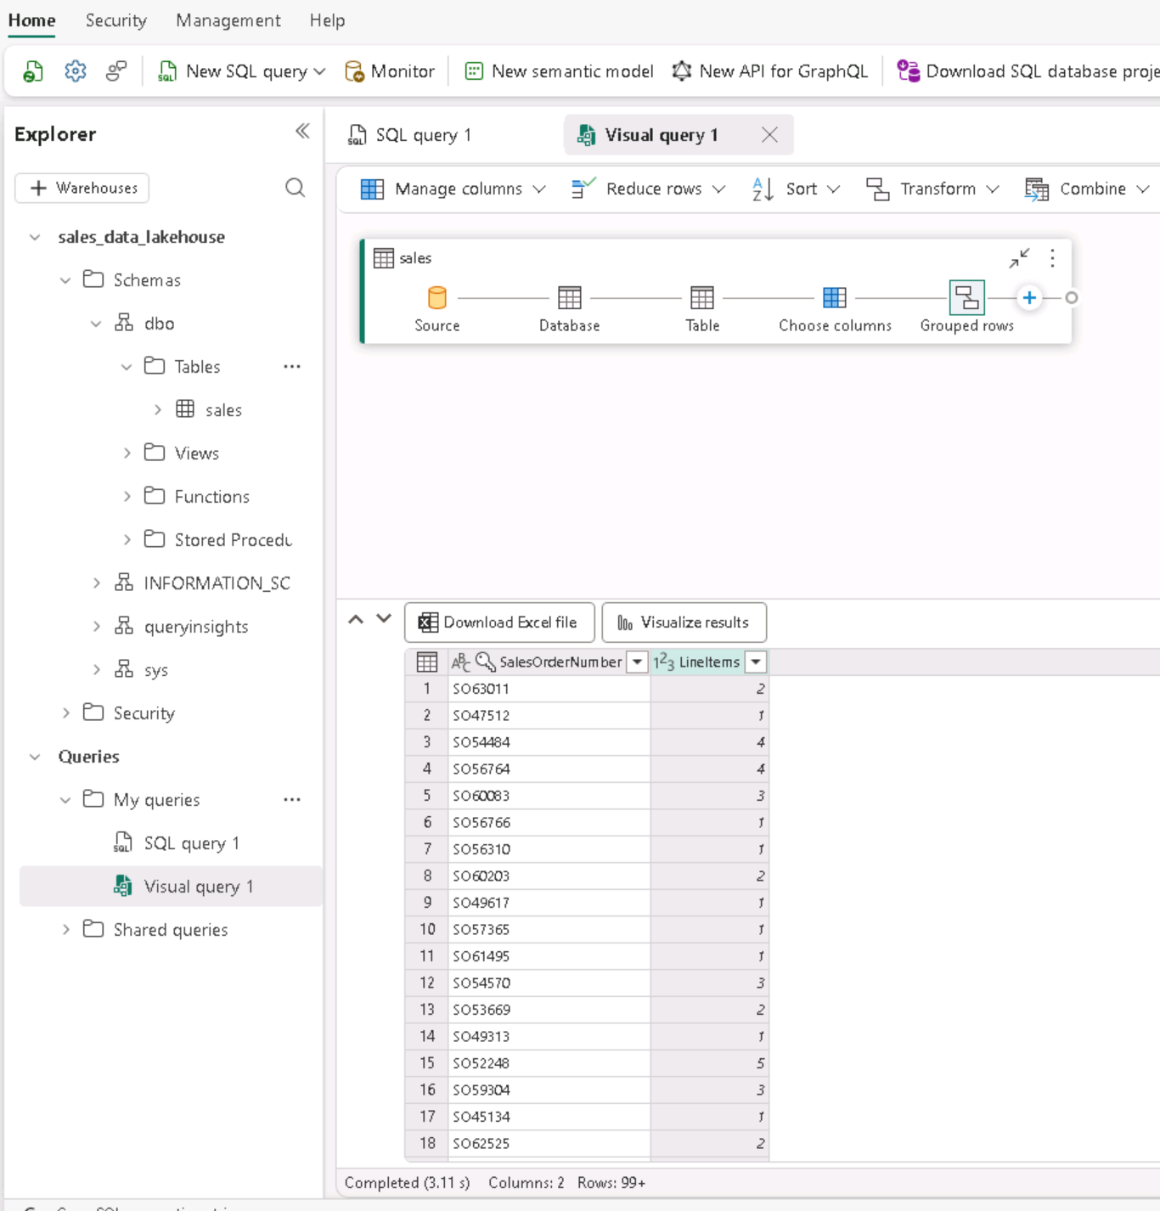

Wrap up
In this assignment we created a lakehouse uploaded a csv file, which is unstructured data, onto datalake data store which is underlying tech for lakehouse. We converted that in a delta table and used SQL to query which is part of warehouse. Lakehouse combines both datalake data store and warehouse to give you flexible environment to work and manage data.
If you are using Microsoft learning labs please don’t forget to delete the workspace by lciking the workspaces icon on the left side hub it will open a window. The window will have your warehouse name click on the “…”. A window will slide out from the right and then scroll down to click on the button Delete this workspace

